EPA Replacement Questionnaire

(PLEASE FILL OUT THIS FORM COMPLETELY)

Date of Sale: Customer Name:

E-Mail Address of where to send core information to: __________________________
End User Name: _______________________________
Is this a John Deere engine being replaced? Yes No
How long has the machine been in service? Model number of the engine core being replaced?

D

D N
Serial number of the engine core being replaced? Type of application (Gen-Set, Irrigation Pump, Air Compressor, etc)?

No
Is the engine being replaced a current Tier engine? Yes
D
If no, What type of certification does it have?
OEM Equipment Manufacturer:

Customer Name: Signature:
Date: ___________________________________
ENGINE CORE RETURN INSTRUCTIONS

Please Email the completed core inspection form along with the information below to core@bellpower.com

Ship From Address

Company Name

Street address

City
State Zip

Phone Number Fax Number

Contact Name

Email Address ______________________________________________

Shipping Hours

Once we receive both completed forms we will schedule a pick-up within a few days.
- We will fax a bill of lading and pro number address labels along with a packing slip back to the email address above
- The packing slip must be attached to the core in a protective envelope and then the core must be wrapped in plastic wrap or covered with a plastic bag to prevent oil and dirt from contaminating other freight. You then need to attach the pro address label supplied to the outside of the core. YOU MUST USE THE PRO LABELS SUPPLIED!
- Ensure all fluids have been drained from the core engine and drain plugs re-installed. The oil pan should be free from all oils and fluids except for normal drainage that may occur during shipment.
- All cores must be returned with all plugs installed and all openings plugged or protected. Cores that do not meet the "dry engine" requirements will have the core value reduced by $150.00.
- Failure to fill out and follow all instructions could result in no core credit.
- Once cores are received and inspected at final destination you will receive proper credit.

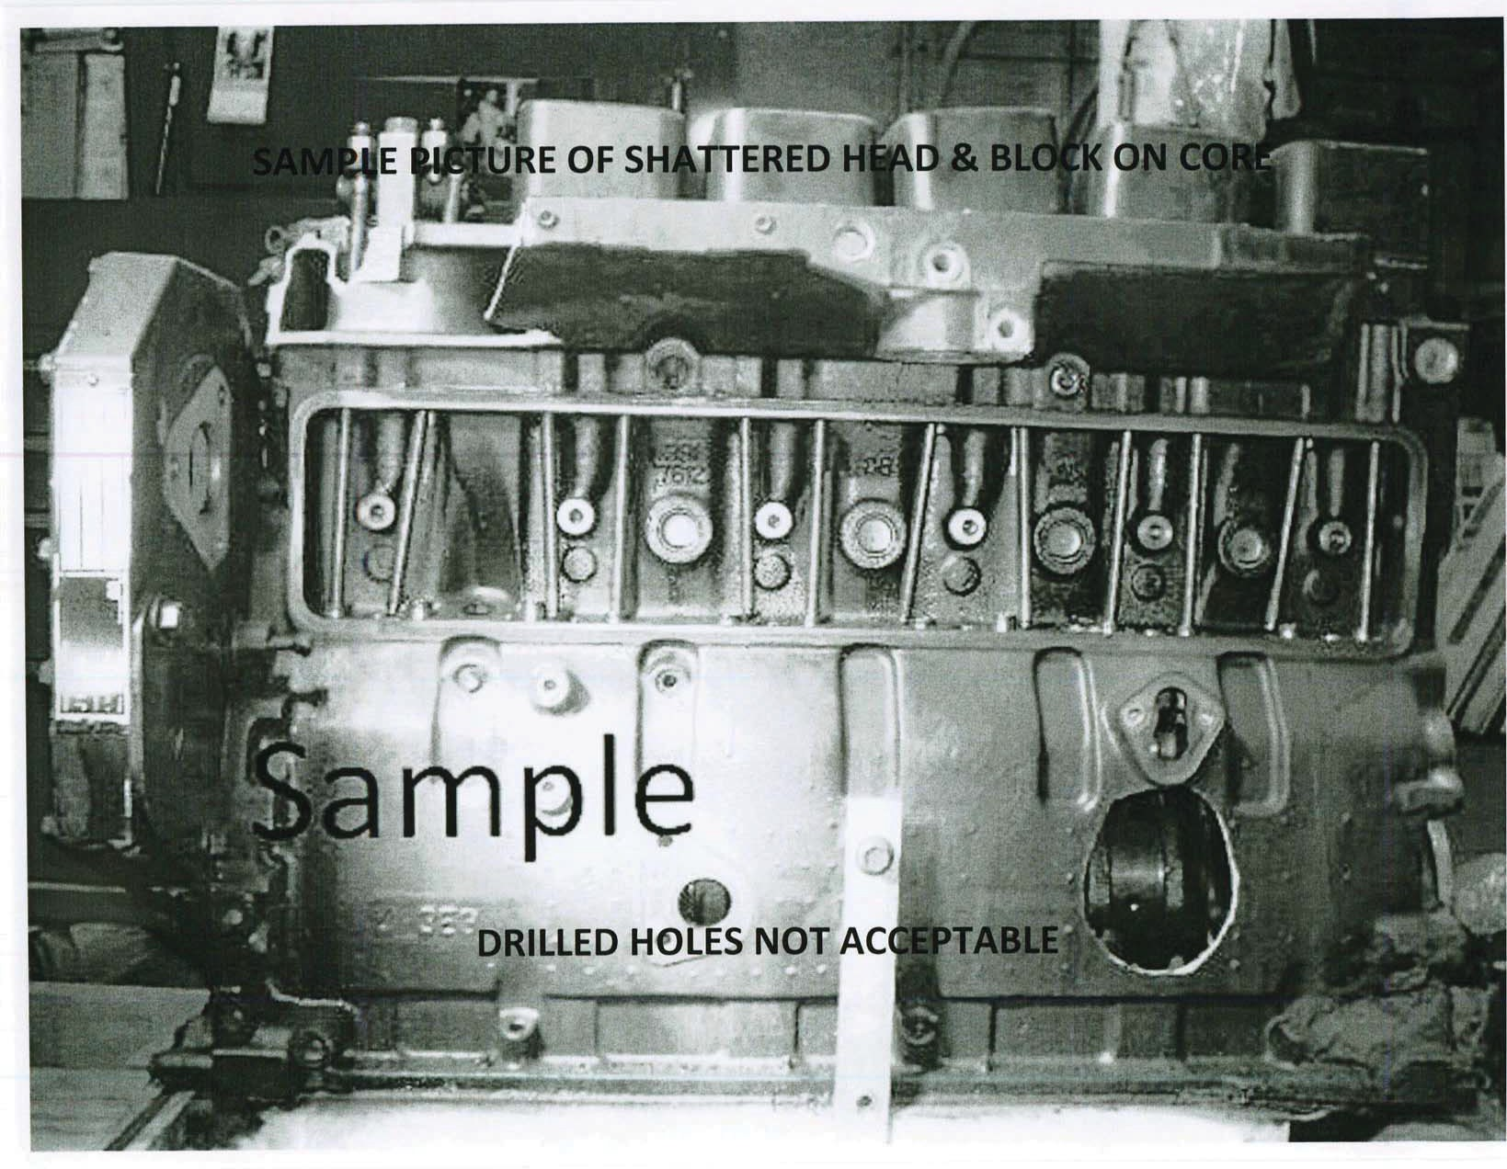
&YBNQMF 'PS /PO-+PIO %FFSF ($PNQFUJUJWF ) $PSFT 0OMZ

FOR COMPETITIVE ENGINE CORES ONLY!!!

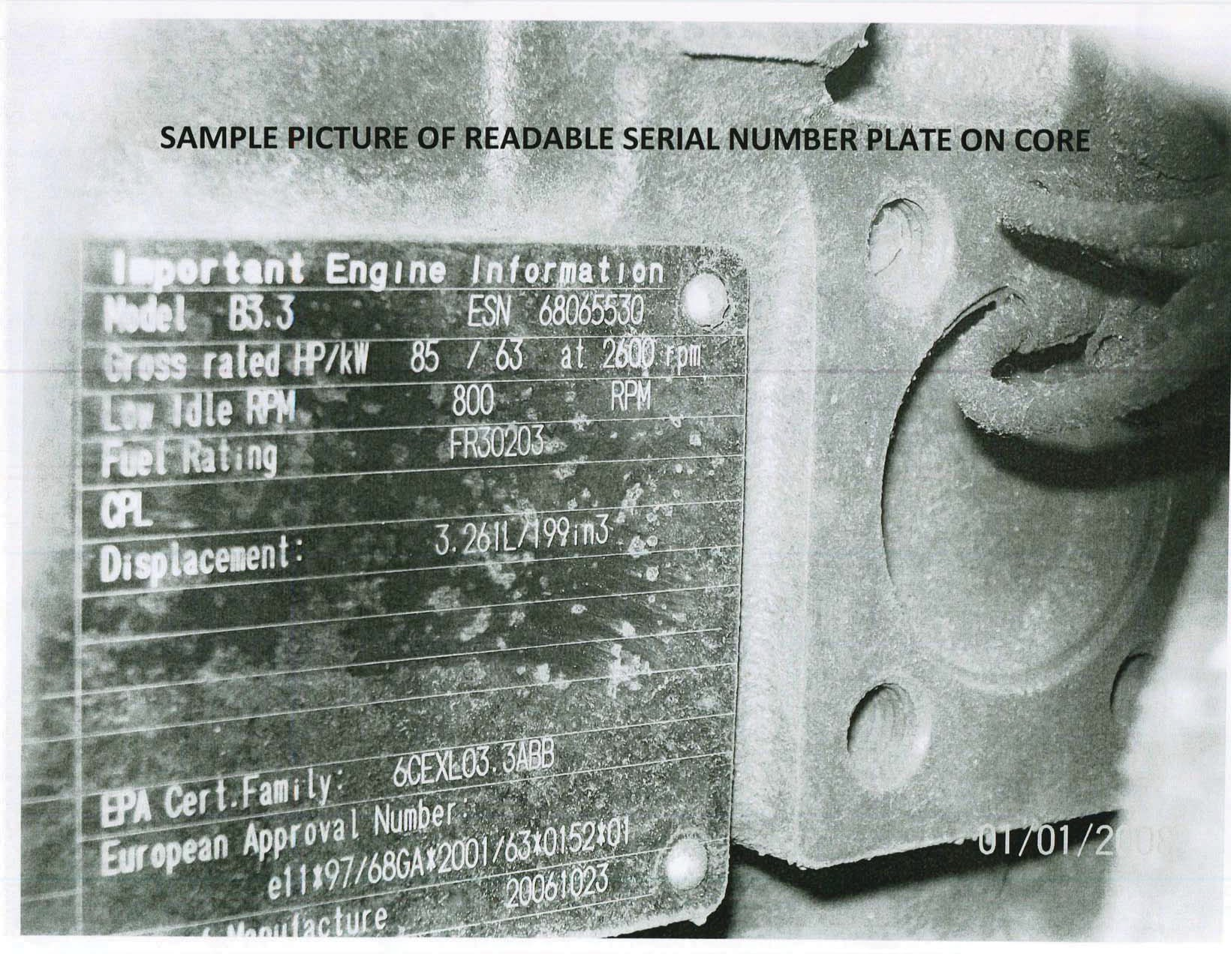
&YBNQMF 'PS /PO-+PIO %FFSF ($PNQFUJUJWF ) $PSFT 0OMZ

FOR COMPETITIVE ENGINE CORES ONLY!!!

