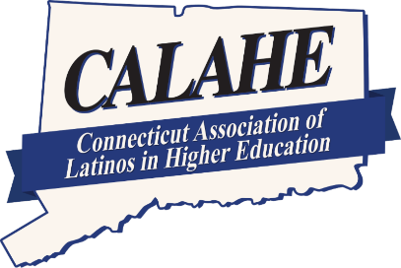
The Connecticut Association of Latinos in Higher Education
CCSU, Willard DiLoreto Hall, Suite D311, 1615 Stanley Street, New Britain, CT 06050

Individual Donation:
SCHOLARSHIP
Donation Form

Address:

(Name of Donor/s)

(Street)

(City) (State) (Zip)

(Daytime telephone) (Email)

My gift to CALAHE Scholarship is:

$500.00 $300.00 $200.00 $100.00 Other

I would like to make my gift in the form of:

• Check (Please make payable to CALAHE Scholarship)

• Credit card/ account name

• Credit Card # Exp. date

(Donor Signature) (Date)

Please remit this form to:
CALAHE
C/O Myrna Garcia-Bowen
CCSU-Willard DiLoreto Hall, Suite D311
New Britain, CT 06050
Many employers will match donations made by their employees.
Obtain the appropriate form from your personnel office and send it to CALAHE with your gift.
Your gift is tax deductible as provided by law

WWW.CALAHE.ORG

